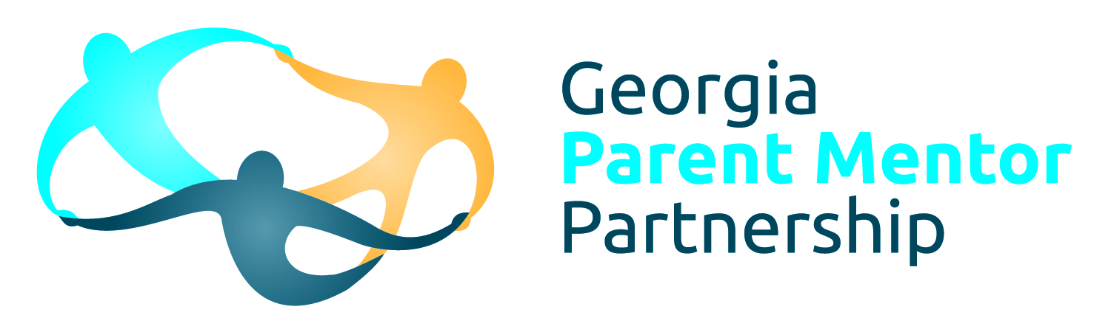
Jane Grillo – White County Schools Parent Mentor
136 Warriors Path, Cleveland, Ga 30528 706-865-2315 ext. 1312 jgrillo@white.k12.ga.us

You may not be familiar with the Georgia Parent Mentor Partnership… so, I wanted to share a little bit about the Parent Mentor partnership and me…
The Georgia Parent Mentor Partnership is an initiative by the Georgia Department of Education, created to improve the relationship between parents (and guardians)whose children receive special education services and school. I do not get paid out of local school taxes and I am not a certified teacher. This is my sixth year as White County Schools Parent Mentor.
My husband Jerry and I are the parents of two children. Samantha is a graduate of WCHS (Class of 2005) and UNG (Class of 2009) and now lives in Michigan. Joey is a 6th grader.
It is important for you to know that every parent mentor must have a child who has received special education services. Joey is in the self-contained classroom with Julie Collins and he also receives PT, OT, speech and participates in inclusive activities through his connections classes.
I am active in numerous disability and community related organizations including: The Georgia Mountains Transition Alliance, Parent to Parent of Ga., Dawson, White, Lumpkin Navigator Team, and the Local Interagency Planning Team, and Pilot International.
I believe in public education and the importance of community support and grassroots advocacy. I also strongly believe that when parents are actively involved in their child’s education (whether they are receiving special education services or not,) children do better in school, and life beyond school.
I am available for parents by cell phone 706-201-0483, at my office in White County Schools Student Services office, 706-865-2315 ext 1312 or by email jgrillo@white.k12.ga.us . I also try to make myself available to parents through home visits and trainings and educational meetings throughout the year.

Looking forward to a wonderful school year!

Jane Grillo

