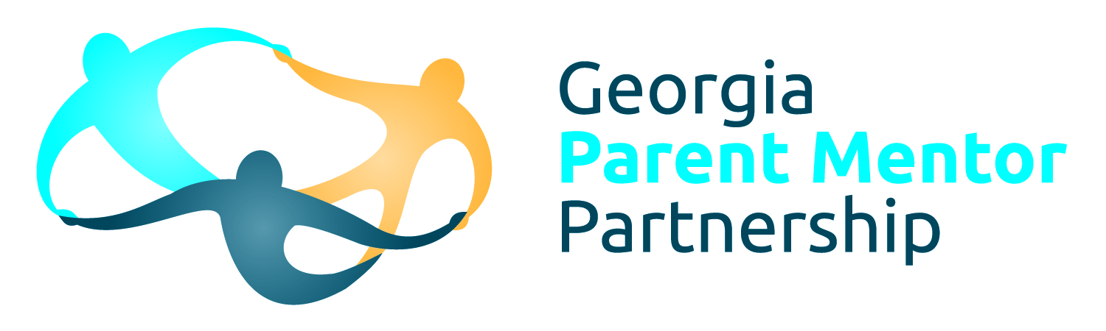
From Sabrinia Gresham, Original Parent Mentor Pilot Group Member

I believe you were part of the pilot group that began the GaPMP right?
Yes I was part of the pilot group that began the partnership. The original group included mentors from the following counties: Catoosa (Melissa Guinn) DeKalb (Mandy Griffin) Fayette (Nick Harris) Fulton (me) Grady (Suzanne Thomas).

When was that?
I actually began on March 25, 2002

Describe your first meeting as a parent mentor? Who was in the meeting? What were your impressions of it? When was it? What was the emphasis on in those days?
My first meeting was on the day I started the job. It was a meeting at the DOE, I attended the meeting with my Director of Instruction (Sara Snyder). This was a meeting to introduce the mentors selected in each county to the staff that would be working with us at the DOE and to each other. All five mentors were present I’m not sure if all the directors were present at that meeting. Phil Pickens facilitated the meeting, I remember each mentor had an opportunity to introduce ourselves and share I thoughts about the program. I remember being so excited. My daughter was ten years old and until this meeting, I never considered that there were people at the DOE concerned about her education. I remember saying something like it was like being in the middle of a candy dish. I was totally out of my element. Phil Pickens actually made references to my comment later during that meeting and I felt much better. That is just who he was. In addition to Phil Pickens, Patti Solomon was there and Susan McKenzie. They all seemed eager to make sure we had what we needed to succeed in this new program.

The emphasis for us was to educate ourselves first in order for us to be able to share accurate information with families. The next step was to become familiar with school staff and the protocol to use when working with families. We also become familiar with disability organizations and created resource libraries for our department. The first year was really immersion in the disability world because up to that point, our focus was limited to our child and our school experience.

How long did it take you to really feel like you knew what your role was in your district?
It wasn’t until the third year of working that I felt I understood all the pieces of the puzzle and was able to begin to navigate effectively in my district.

What have been the biggest changes you have noticed in the GaPMP over the years?
The growth of the program has been wonderful to see however it does limit our ability to connect with each other on a personal level. The structure created by the Regional Representatives has been another change for the good as well as having our own website.

What family engagement initiative are you most proud of?
I was really happy to have the opportunity to create parent resource libraries for all of our center schools at the elementary and middle school levels. I was also happy to be part of a team that had discussions with our Executive Director that led to the creation of an online manual to assist all SEC families in our county as they navigated Special Education. It took a long time and a lot of effort to get to this point.

What would you like rookies to know?
I want them to know that you eat an elephant one bite at a time. Don’t let the size of the job overwhelm you. You don’t have to have all the answers know where to find them. When you meet someone that makes you question whether your work is valuable just remember the sound of relief you hear in a parent’s voice after you have provided support to them. Your child has made you an expert in your field, don’t hesitate to share what you know. If you ever need help you have lots of people to call or email. You are a gift! Thank you for the support that you give to families in Georgia!

